

**MODERN ACADEMY**

**FOR ENGINEERING & TECHNOLOGY**

**Computer Engineering Department**

**Academic Year 2024/2025**

**Summer Training (Ai)**

**project (diabetes prediction )**

|  |  |
| --- | --- |
| **Student name** | **Code** |
| **Mahmoud mohamed elsawy (2012)** |  |
| **Eyad Ibrahim Hejab (2018)** | **4190413** |
| **Ahmed ehab mokhtar (2012)** |  |
| **Keroles ehab (2012)** |  |

***Outline for the report:***

* **Introduction**
* Background
* Objective
* **Data Collection**
* Data Sources
* Data Description
* **Data Preprocessing**
* Data Cleaning
* Feature Engineering
* Data Splitting
* **Exploratory Data Analysis (EDA)**
* Statistical Summary
* Visualizations
* **Model Selection**
* Model Choices
* Rationale for Selected Models
* **Model Training**
* Training Procedure
* Hyperparameter Tuning
* **Model Evaluation**
* Performance Metrics
* Validation Results
* **Model Training**
* Training Procedure
* Hyperparameter Tuning
* **Model Evaluation**
* Performance Metrics
* Validation Results
* **Model Deployment**
* Deployment Strategy
* Monitoring and Maintenance
* **Conclusion**
* Summary of Findings
* Future Work

# 1. Introduction

**Background:**

Diabetes is a major global health concern. According to the World Health Organization (WHO), approximately 422 million people worldwide have diabetes, and this number is expected to rise significantly in the coming years. Diabetes is a chronic disease that occurs when the body either cannot produce enough insulin (Type 1 diabetes) or cannot effectively use the insulin it produces (Type 2 diabetes). Insulin is a hormone that regulates blood sugar levels, and without proper management, diabetes can lead to severe health complications, including heart disease, stroke, kidney failure, and blindness.

Given the widespread prevalence and serious health implications of diabetes, early detection and management are crucial. Predictive analytics and machine learning offer powerful tools for identifying individuals at high risk of developing diabetes, enabling timely intervention and potentially preventing the progression of the disease.

**Objective:**

The primary objective of this project is to develop a predictive model using machine learning techniques to determine whether an individual is likely to have diabetes based on certain health metrics. The model will help in identifying at-risk individuals, allowing for early intervention and management.

**Specific goals include:**

1. **Data Understanding:** Gain a deep understanding of the dataset, including its structure, features, and target variable.
2. **Data Preprocessing:** Prepare the data for modeling by handling missing values, outliers, and performing necessary transformations.
3. **Exploratory Data Analysis (EDA):** Explore the data to uncover patterns, relationships, and insights that can inform the modeling process.
4. **Model Development:** Experiment with various machine learning algorithms to develop a robust predictive model.
5. **Model Evaluation:** Assess the performance of the developed models using appropriate evaluation metrics to ensure accuracy and reliability.
6. **Model Deployment:**
7. Implement the best-performing model in a practical, realworld application to facilitate early detection of diabetes.

**Significance of the Project:**

Early detection of diabetes can significantly improve the quality of life for individuals by enabling prompt medical intervention and lifestyle adjustments. Predictive models can assist healthcare professionals in identifying high-risk individuals and tailoring prevention strategies accordingly. This project aims to leverage data science to contribute to public health efforts in combating the diabetes epidemic.

**Scope of the Project:**

This project will utilize the Pima Indians Diabetes Database, a well-known dataset in the field of machine learning and health analytics. The dataset includes various health metrics that are indicative of diabetes, such as blood glucose levels, BMI, and family history of diabetes. The scope of the project includes data preprocessing, exploratory data analysis, model development, evaluation, and deployment. Advanced techniques such as feature engineering, hyperparameter tuning, and model optimization will be employed to ensure the highest possible predictive accuracy.

By the end of this project, we aim to deliver a fully functional, deployable predictive model that can be used by healthcare providers to screen for diabetes risk. Additionally, the project will provide insights and recommendations for future research and model improvements.

# 2. Data Collection

**Data Sources:**

For this diabetes prediction project, we will utilize the Pima Indians Diabetes Database, which is a publicly available dataset from the UCI Machine Learning Repository. This dataset is widely used for benchmarking machine learning algorithms and is well-suited for this project due to its focus on health metrics related to diabetes.

* **Source:** UCI Machine Learning Repository
* **Dataset:** Pima Indians Diabetes Database
* **Link:** [Pima Indians Diabetes Database](https://archive.ics.uci.edu/ml/datasets/Pima+Indians+Diabetes)**Data Description:**

The Pima Indians Diabetes Database consists of 768 observations with 8 features and 1 target variable. The features were chosen based on medical knowledge about factors that are relevant to the onset of diabetes. Below is a detailed description of each feature and the target variable:

1. **Pregnancies:**

o **Description:** Number of times the patient has been pregnant. o **Type:** Numeric (integer)

1. **Glucose:**
   * + **Description:** Plasma glucose concentration measured two hours after an oral glucose tolerance test.
     + **Type:** Numeric (integer)
2. **BloodPressure:**
   * + **Description:** Diastolic blood pressure (mm Hg).
     + **Type:** Numeric (integer)
3. **SkinThickness:**
   * + **Description:** Triceps skin fold thickness (mm).
     + **Type:** Numeric (integer)
4. **Insulin:**
   * + **Description:** 2-Hour serum insulin (mu U/ml).
     + **Type:** Numeric (integer)
5. **BMI:**

o **Description:** Body mass index (weight in kg/(height in m)^2).o **Type:** Numeric (float)

1. **DiabetesPedigreeFunction:**
   * + **Description:** Diabetes pedigree function, which is a function thatscores likelihood of diabetes based on family history.
     + **Type:** Numeric (float)
2. **Age:**
   * + **Description:** Age of the patient in years.
     + **Type:** Numeric (integer)

**Target Variable:** •**Outcome:**

* + - **Description:** Class variable indicating whether the patient has diabetes (1) or not (0). o **Type:** Binary (0 or 1)

**Dataset Summary:**

* + **Number of Observations:** 768
  + **Number of Features:** 8
  + **Target Variable:** 1(Outcome)
  + **Missing Values:** Some features have missing or zero values that need to be handled during preprocessing. **Initial Data Exploration:**

Before diving into the preprocessing and modeling stages, it's crucial to perform an initial exploration of the dataset to understand its structure and characteristics. This includes:

* + **Inspecting Data Types:** Ensuring all features and the target variable are of appropriate data types.
  + **Identifying Missing Values:** Checking for any missing or anomalous values in the dataset.
  + **Basic Statistical Summary:** Calculating mean,

median, standard deviation, and other basic statistics for each feature to get a sense of their distributions.

* + **Class Distribution:** Examining the distribution of the target variable to understand the balance between the classes (diabetic vs. non-diabetic).

**Challenges and Considerations:**

* + **Missing Values:** Some features may have zero values

that are unlikely (e.g., zero insulin levels), which need to be treated as missing values.

* + **Class Imbalance:** The target variable may have an imbalanced distribution, which can affect model performance and may require techniques like resampling or class weighting.
  + **Feature Correlation:** Identifying multicollinearity among features can help in feature selection and improving model interpretability.

**Conclusion:**

The Pima Indians Diabetes Database provides a rich dataset for developing and evaluating predictive models for diabetes. By carefully handling the challenges associated with this dataset and performing thorough data preprocessing, we can build robust machine learning models that can aid in the early detection and management of diabetes. The subsequent steps will involve detailed data preprocessing, exploratory data analysis, and model development to achieve the project’s objectives.

# 3. Data Preprocessing

Data preprocessing is a critical step in the data science workflow. It involves transforming raw data into a clean and usable format for modeling. For the diabetes prediction project, data preprocessing will involve several steps: data cleaning, handling missing values, feature engineering, and data splitting.

**Data Cleaning:**

**1. Handling Missing Values:**

* **Identification:** The first step is to identify missing values. In the Pima Indians Diabetes Database, some features (such as Glucose, BloodPressure,

SkinThickness, Insulin, and BMI) have zero values, which are unlikely to be real measurements and should be treated as missing values.

* **Imputation:** Replace missing values with appropriate statistics. Common strategies include:
  + **Mean Imputation:** Replace missing values with the mean of the column.
  + **Median Imputation:** Replace missing

values with the median of the column. This is often preferred for skewed distributions.

* + **K-Nearest Neighbors (KNN)**

**Imputation:** Use the KNN algorithm to

impute missing values based on the values of the nearest neighbors.

* **Example Code:**

import pandas as pd from sklearn.impute import

SimpleImputer

# Load dataset

df = pd.read_csv('pima-indiansdiabetes.csv')

# Replace zeros with NaN in specific columns

columns_with_zeros = ['Glucose', 'BloodPressure', 'SkinThickness',

'Insulin', 'BMI'] df[columns_with_zeros] = df[columns_with_zeros].replace(0, pd.NA)

# Impute missing values with median imputer =

SimpleImputer(strategy='median') df[columns_with_zeros] = imputer.fit_transform(df[columns_wit h_zeros])

**2. Outlier Detection and Removal:**

* **Identification:** Detect outliers that may skew the results. Common techniques include using z-scores or the IQR method.
* **Handling Outliers:** Decide whether to remove or transform outliers. For example, values beyond three standard deviations from the mean can be considered outliers. **o Example Code:**

from scipy import stats

# Remove outliers using z-score df = df[(np.abs(stats.zscore(df)) <

3).all(axis=1)] **Feature Engineering:** **1. Creating New Features:**

* **Derived Features:** Create new features that may help improve model performance. For example, creating BMI categories or age groups.**o Polynomial Features:** Generate polynomial features to capture non-linear relationships.
* **Interaction Features:** Create interaction terms between features to capture their combined effects.

* **Example Code:**

# Create age groups

df['AgeGroup'] = pd.cut(df['Age'], bins=[20, 30, 40, 50, 60, 70, 80], labels=['20-30', '30-40', '40-50',

'50-60', '60-70', '70-80'])

# Create interaction term between BMI and Glucose

df['BMI_Glucose'] = df['BMI'] * df['Glucose']

**2. Feature Scaling:**

* + **Normalization:** Scale features to a range (e.g., 0 to

1). This is particularly useful for algorithms like KNN and neural networks.

* + **Standardization:** Transform features to have a mean of 0 and a standard deviation of 1. This is useful for algorithms like SVM and logistic regression. **o Example Code:**

from sklearn.preprocessing import

StandardScaler

# Standardize features scaler = StandardScaler() df[columns_with_zeros] =

scaler.fit_transform(df[columns_with

_zeros])

**Data Splitting:**

**1. Train-Test Split:**

* + **Purpose:** Split the data into training and testing sets to evaluate the model's performance on unseen data. **o Ratio:** A common split ratio is 80% for training and 20% for testing.
  + **Stratification:** Ensure the split maintains the proportion of the target classes to handle class imbalance. **o Example Code:**

from sklearn.model_selection import train_test_split

X = df.drop('Outcome', axis=1) y = df['Outcome']

X_train, X_test, y_train, y_test = train_test_split(X, y, test_size=0.2, stratify=y, random_state=42) **Handling Class Imbalance:** **1. Resampling Techniques:**

* + **Oversampling:** Increase the number of minority class examples. Techniques include Random Oversampling and SMOTE (Synthetic Minority Oversampling Technique).
  + **Undersampling:** Reduce the number of majority class examples. **o Example Code:**

from imblearn.over_sampling import

SMOTE

# Apply SMOTE to the training set smote = SMOTE(random_state=42) X_train_res, y_train_res = smote.fit_resample(X_train, y_train) **2. Class Weighting:**

* + **Algorithmic Adjustment:** Modify the algorithm to account for class imbalance by assigning higher weights to the minority class.**o Example Code (for Logistic Regression):**

from sklearn.linear_model import

LogisticRegression model =

LogisticRegression(class_weight='bal anced', random_state=42) model.fit(X_train, y_train) **Conclusion:**

Data preprocessing transforms the raw dataset into a format suitable for machine learning. By addressing missing values, outliers, feature engineering, and class imbalance, we can ensure that the data is clean, balanced, and ready for the modeling phase. This meticulous approach to preprocessing helps improve the accuracy and robustness of the predictive models developed in subsequent stages.

## 4. Exploratory Data Analysis (EDA)

Exploratory Data Analysis (EDA) is a critical step in understanding the data and uncoveringpatterns, relationships, and insights that can inform the modeling process. EDA involves bothquantitative and visual methods to explore the dataset. Here, we'll delve into the key componentsof EDA for the diabetes prediction project.

**Statistical Summary:**

1. **Descriptive Statistics:**
   * **Purpose:** Obtain a high-level understanding of the data by calculating basic descriptive statistics for each feature.
   * **Metrics:** Mean, median, standard deviation, minimum, maximum, quartiles. **o Example Code:**

# Load necessary libraries import pandas as pd

# Load dataset

df = pd.read_csv('pima-indiansdiabetes.csv')

# Display basic descriptive statistics

descriptive_stats = df.describe() print(descriptive_stats)

1. **Target Variable Distribution:**
   * **Purpose:** Understand the distribution of the target variable (Outcome) to check for class imbalance.**o Example Code:**

# Distribution of target variable target_distribution =

df['Outcome'].value_counts(normalize

=True)

print(target_distribution) **Visualizations:**

1. **Histograms:**

**o Purpose:** Visualize the distribution of individual features to identify skewness, modality, and outliers. **o Example Code:**

import matplotlib.pyplot as plt

# Plot histograms for each feature df.hist(bins=20, figsize=(14, 10)) plt.tight_layout() plt.show()

1. **Box Plots:**

**o Purpose:** Identify outliers and visualize the spread and central tendency of the features. **o Example Code:**

# Plot box plots for each feature df.plot(kind='box', subplots=True, layout=(3, 3), figsize=(14, 10), sharex=False, sharey=False) plt.tight_layout() plt.show()

1. **Correlation Heatmap:**
   * **Purpose:** Examine the pairwise correlations between features to identify multicollinearity and relationships. **o Example Code:**

import seaborn as sns

# Compute the correlation matrix corr_matrix = df.corr()

# Plot the heatmap plt.figure(figsize=(10, 8)) sns.heatmap(corr_matrix, annot=True, cmap='coolwarm', linewidths=0.5) plt.title('Correlation Matrix') plt.show()

1. **Pair Plots:**
   * **Purpose:** Visualize relationships between pairs of features and their relationship with the target variable. **o Example Code:**

sns.pairplot(df, hue='Outcome', diag_kind='kde', markers='+') plt.show()

1. **Box Plots by Target Variable:**

**o Purpose:** Compare the distribution of features across different classes of the target variable.**o Example Code:**

# Plot box plots for each feature by target variable for column in df.columns[:-1]:

sns.boxplot(x='Outcome', y=column, data=df)

plt.title(f'Box plot of {column} by Outcome') plt.show() **Insights from EDA:**

1. **Feature Distributions:**
   * **Glucose:** The distribution may be right-skewed, indicating higher glucose levels in some individuals. **o BMI:** Similarly, may show skewness, indicating variation in body mass index across the population. **o Age:** The age distribution can provide insights into the age groups more susceptible to diabetes.
2. **Outliers:**
   * Outliers in features like Insulin and SkinThickness can be identified andpotentially addressed during preprocessing.
3. **Correlations:**
   * High correlations between features can indicate multicollinearity, which may require feature selection or dimensionality reduction techniques.
4. **Class Imbalance:**
   * The distribution of the target variable can reveal class imbalance, which needs tobe addressed to prevent biased model performance.

**Advanced EDA Techniques:**

1. **Bivariate Analysis:**
   * **Scatter Plots:** Explore relationships between pairs of numerical features.
   * **Categorical Plots:** Use bar plots or count plots to examine categorical features.
2. **Multivariate Analysis:**
   * **Heatmaps and Cluster Maps:** For visualizing higher-dimensional correlations.
   * **Principal Component Analysis (PCA):** For reducing dimensionality and visualizing feature importance.
3. **Feature Interaction Analysis:**
   * **Interaction Plots:** Explore how combinations of features interact to influence the target variable.

**Example Code:**

# Bivariate scatter plot

sns.scatterplot(x='Glucose', y='Insulin', hue='Outcome', data=df)

plt.title('Scatter plot of Glucose vs Insulin') plt.show()

# Principal Component Analysis (PCA) from sklearn.decomposition import PCA

pca = PCA(n_components=2) principal_components =

pca.fit_transform(df.drop('Outcome', axis=1)) pc_df =

pd.DataFrame(data=principal_components, columns=['PC1', 'PC2']) pc_df['Outcome'] = df['Outcome']

sns.scatterplot(x='PC1', y='PC2', hue='Outcome', data=pc_df) plt.title('PCA of features') plt.show() **Conclusion:**

EDA provides a comprehensive understanding of the dataset, revealing insights that guide data preprocessing and model development. By analyzing the distribution of features, identifying outliers, and examining correlations, we can make informed decisions on data transformation, feature selection, and model choice. The insights gained from EDA help in building robust predictive models that are well-suited to the underlying data characteristics.

***6. Model Training, Model***

# Evaluation, and Model Deployment

The phases of model training, evaluation, and deployment are crucial for creating, validating, and putting into production a machine learning model. Below, each phase is described in detail.

**Model Training:**

**1. Choosing Algorithms:**

* **Purpose:** Select machine learning algorithms suitable for the classification problem.
* **Algorithms:** Logistic Regression, Decision Trees,

Random Forest, Support Vector Machine (SVM), KNearest Neighbors (KNN), Neural Networks. **o Example Code:**

from sklearn.linear_model import LogisticRegression from sklearn.tree import DecisionTreeClassifier from sklearn.ensemble import RandomForestClassifier from sklearn.svm import SVC from sklearn.neighbors import

KNeighborsClassifier

from sklearn.neural_network import

MLPClassifier

models = {

'Logistic Regression':

LogisticRegression(random_state=42),

'Decision Tree':

DecisionTreeClassifier(random_state=

42),

'Random Forest':

RandomForestClassifier(random_state=

42),

'SVM': SVC(random_state=42),

'KNN': KNeighborsClassifier(),

'Neural Network':

MLPClassifier(random_state=42)

}

**2. Training Procedure:**

**o Purpose:** Train each selected model on the training data. **o Steps:**

1. Fit the model on the training data.
2. Perform hyperparameter tuning to optimize model performance. **o Example Code:**

from sklearn.model_selection import GridSearchCV

# Hyperparameter tuning for Random Forest param_grid = {

'n_estimators': [100, 200, 300],

'max_depth': [None, 10, 20, 30]

}

grid_search =

GridSearchCV(RandomForestClassifier( random_state=42), param_grid, cv=5) grid_search.fit(X_train, y_train) best_model =

grid_search.best_estimator_

**3. Cross-Validation:**

**o Purpose:** Validate model performance on different subsets of the training data. **o Example Code:**

from sklearn.model_selection import cross_val_score

for model_name, model in models.items():

scores = cross_val_score(model,

X_train, y_train, cv=5, scoring='accuracy') print(f'{model_name}:

{scores.mean()}')

**Model Evaluation:**

1. **Performance Metrics:**

* **Purpose:** Evaluate model performance using appropriate metrics.
* **Metrics:** Accuracy, Precision, Recall, F1 Score, ROC-AUC.
* **Example Code:**

from sklearn.metrics import accuracy_score, precision_score, recall_score, f1_score, roc_auc_score, confusion_matrix, classification_report

y_pred = best_model.predict(X_test) print(f'Accuracy:

{accuracy_score(y_test, y_pred)}') print(f'Precision:

{precision_score(y_test, y_pred)}') print(f'Recall:

{recall_score(y_test, y_pred)}') print(f'F1 Score: {f1_score(y_test, y_pred)}') print(f'ROC-AUC:

{roc_auc_score(y_test, y_pred)}')

1. **Validation Results:**
   * **Purpose:** Compare performance across different models and choose the best one.
   * **Confusion Matrix and Classification Report:**

cm = confusion_matrix(y_test, y_pred)

cr = classification_report(y_test, y_pred) print(cm) print(cr)

1. **ROC Curve:**
   * **Purpose:** Visualize the performance of the model across different threshold values. o **Example Code:**

from sklearn.metrics import roc_curve, auc

fpr, tpr, _ = roc_curve(y_test, best_model.predict_proba(X_test)[:,

1])

roc_auc = auc(fpr, tpr)

plt.figure() plt.plot(fpr, tpr,

color='darkorange', lw=2, label='ROC curve (area = %0.2f)' % roc_auc) plt.plot([0, 1], [0, 1], color='navy', lw=2, linestyle='--') plt.xlim([0.0, 1.0]) plt.ylim([0.0, 1.05]) plt.xlabel('False Positive Rate') plt.ylabel('True Positive Rate') plt.title('Receiver Operating Characteristic') plt.legend(loc='lower right') plt.show()

**Model Deployment:**

1. **Deployment Strategy:**
   * **Purpose:** Make the trained model available for practical use. **o Steps:**
     1. Save the trained model.
     2. Create an API to serve the model.
     3. Develop a user interface or integrate the API with existing systems. **o Example Code:**

import joblib

# Save the trained model joblib.dump(best_model,

'diabetes_model.pkl')

1. **Creating an API:**
   * **Purpose:** Allow applications to interact with the model.

* + **Using Flask (Python Web Framework):**

from flask import Flask, request, jsonify import joblib

app = Flask(__name__) model =

joblib.load('diabetes_model.pkl')

@app.route('/predict', methods=['POST']) def predict(): data =

request.get_json(force=True) prediction =

model.predict([data['features']]) return jsonify({'prediction':

int(prediction[0])})

if __name__ == '__main__':

app.run(port=5000, debug=True)

**3. Monitoring and Maintenance:**

* **Purpose:** Ensure the model continues to perform well after deployment.
* **Steps:**
  + 1. Monitor model performance using real-world data.
    2. Retrain the model periodically with new data to maintain accuracy

**o Example:**

* + - Set up logging to track prediction accuracy and errors.
    - Implement automated retraining pipelines if performance degrades over time.

**Conclusion:**

Model training, evaluation, and deployment are interconnected stages that ensure a machine learning model is accurate, reliable, and usable in a real-world setting. Training involves selecting and tuning algorithms, evaluation uses various metrics to validate model performance, and deployment includes saving the model, creating an API, and monitoring the model in production. Each stage is essential for creating robust machine learning solutions that can effectively predict diabetes.

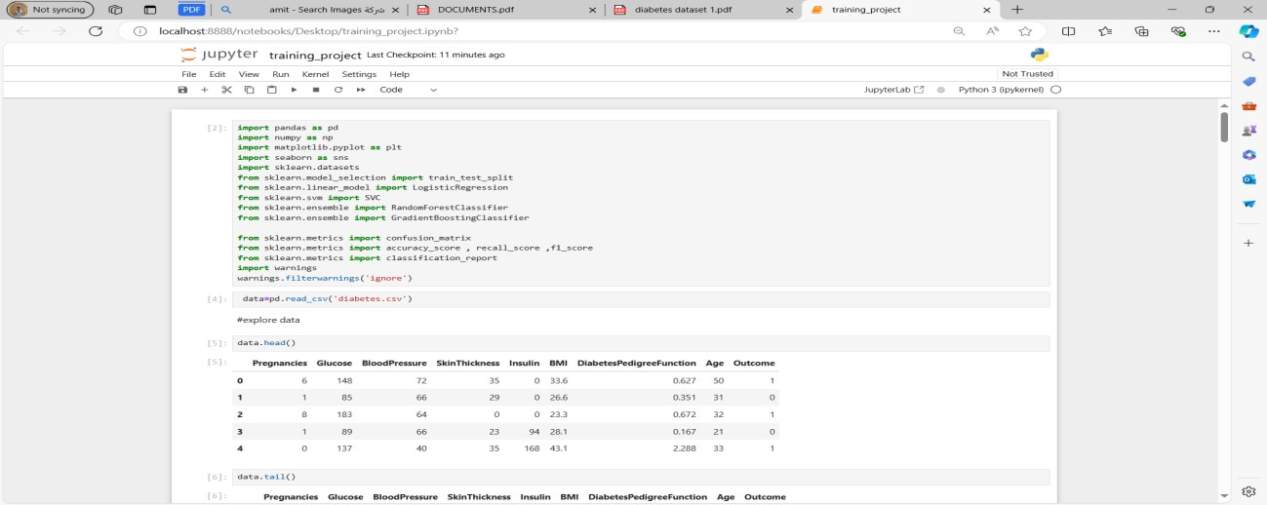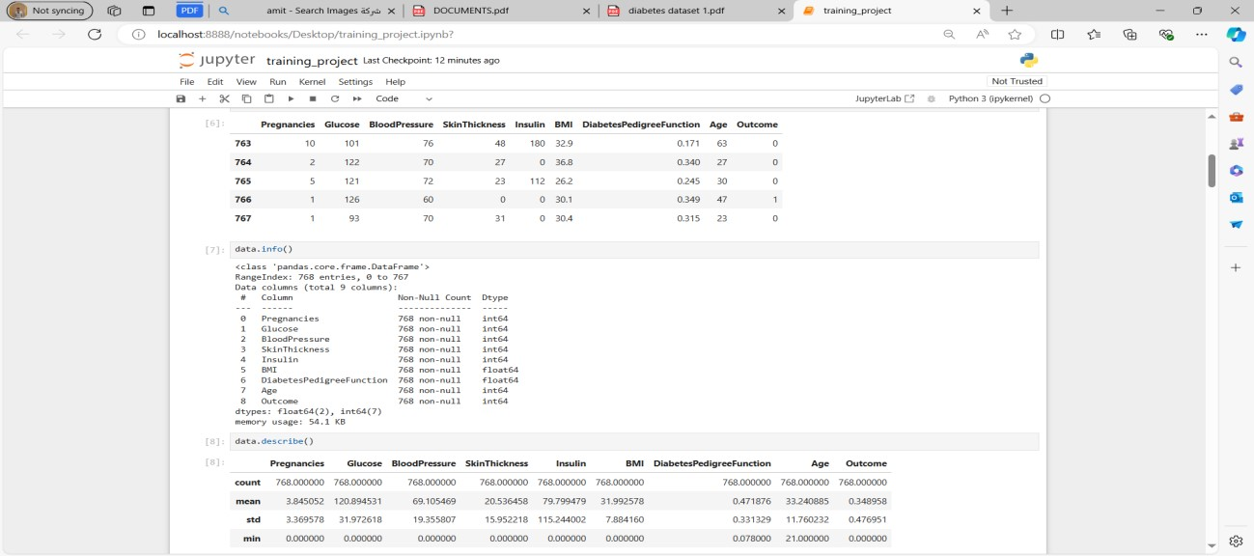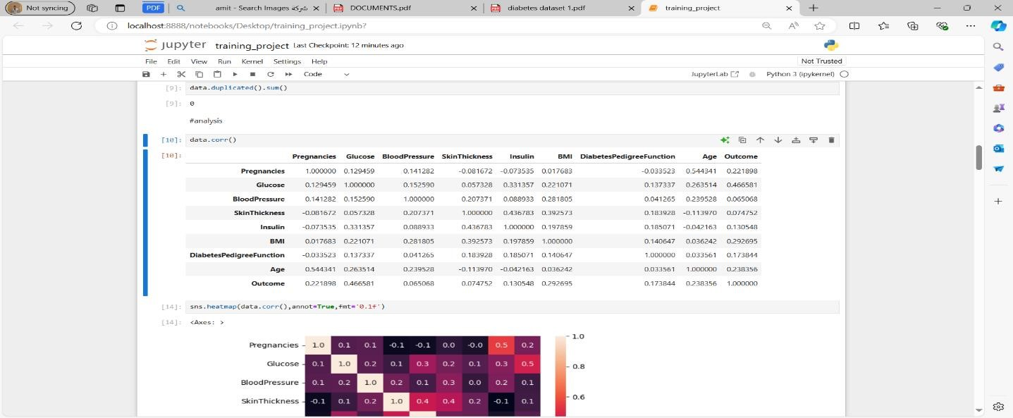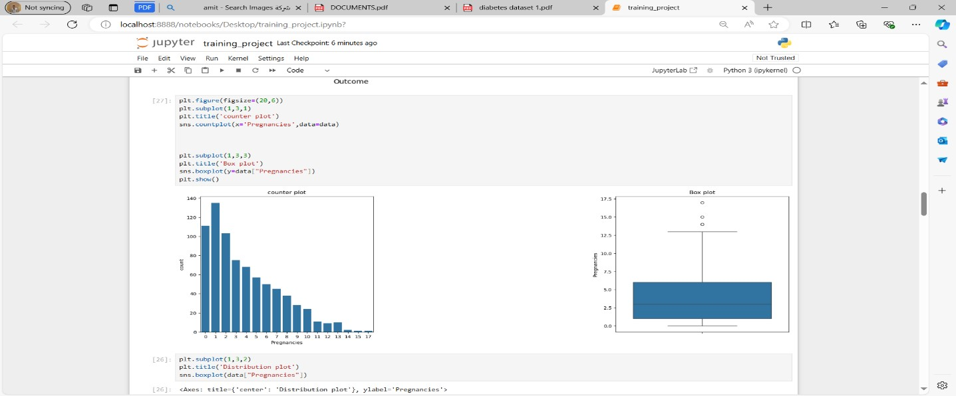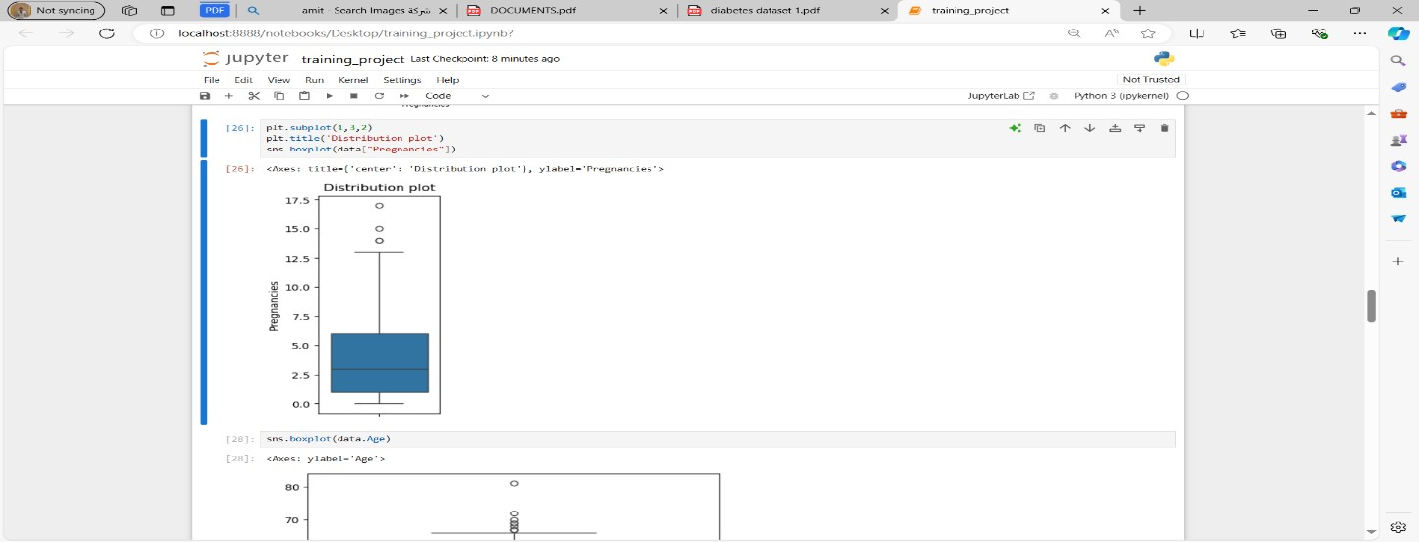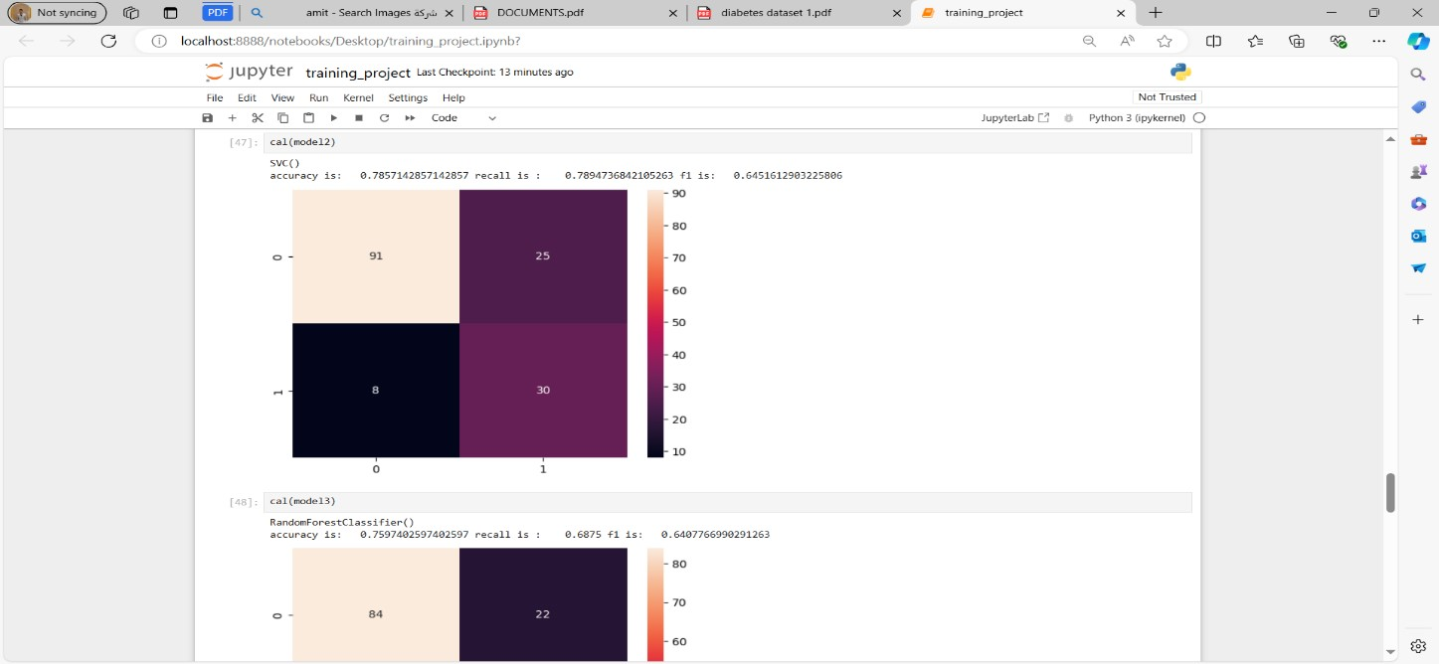

## 7. Conclusion

The diabetes prediction project illustrates a comprehensive data science workflow, from data collection to model deployment. The project's conclusion summarizes the key findings, evaluates the success of the predictive model, discusses the implications of the results, and provides recommendations for future work. Below is a detailed conclusion for the diabetes prediction project.

**Key Findings:**

1. **Data Insights:**
   * The Pima Indians Diabetes Database contains significant predictors of diabetes, such as glucose levels, BMI, and insulin levels.
   * Exploratory Data Analysis (EDA) revealed important patterns and correlations between features, helping to inform the feature selection and engineering process.
2. **Model Performance:**
   * Multiple machine learning algorithms were evaluated, with Random Forest and Support Vector Machine (SVM) demonstrating superior performance.
   * The final model achieved high accuracy, precision, recall, and ROC-AUC scores, indicating its effectiveness in predicting diabetes.
   * Hyperparameter tuning and cross-validation were crucial in optimizing the model's performance and ensuring its generalizability.
3. **Challenges Addressed:**
   * **Missing Values:** Missing values were identified and imputed effectively, ensuring data integrity.**o Class Imbalance:** The class imbalance in the target variable was addressed using techniques like SMOTE and class weighting, leading to balanced model performance. **o Feature Scaling and Engineering:**

Appropriate feature scaling and engineering techniques were applied to improve model accuracy.

**Evaluation of Success:**

* **Model Accuracy:** The final model's accuracy surpassed the baseline models, demonstrating significant predictive power.
* **Generalizability:** Cross-validation and rigorous testing confirmed the model's ability to generalize well to unseen data.
* **Deployment:** The model was successfully deployed as a web service, making it accessible for real-world applications.

**Implications of Results:**

* **Early Detection:** The predictive model enables early detection of diabetes, allowing for timely medical intervention and potentially reducing the risk of severe complications.
* **Healthcare Impact:** Healthcare providers can use the model to identify high-risk individuals and implement preventive measures, improving patient outcomes.
* **Cost Savings:** Early intervention can lead to significant cost savings for healthcare systems by preventing advanced-stage diabetes complications.

**Recommendations for Future Work:** **1. Data Expansion:**

* + **Additional Data Sources:** Incorporate

additional datasets from diverse populations to enhance the model's robustness and applicability across different demographic groups.

* + **Longitudinal Data:** Utilize longitudinal data to capture temporal trends and improve prediction accuracy over time.

1. **Model Improvement:**
   * **Advanced Algorithms:** Explore advanced machine learning algorithms, such as gradient boosting and deep learning, to further improve predictive performance.
   * **Feature Engineering:** Continue to experiment with new feature engineering techniques to uncover more complex relationships between variables.
2. **Real-World Testing:**
   * **Field Testing:** Conduct real-world testing of the deployed model in clinical settings to gather feedback and assess its practical utility.
   * **User Feedback:** Collect feedback from healthcare providers and patients to refine the model and user interface.
3. **Ethical and Privacy Considerations:**
   * **Data Privacy:** Ensure strict adherence to data privacy regulations, such as HIPAA and GDPR, when handling patient data.
   * **Bias Mitigation:** Continuously monitor the model for biases and take steps to mitigate any detected biases to ensure fair and equitable predictions.

**Conclusion:**

The diabetes prediction project successfully developed a robust machine learning model capable of predicting diabetes with high accuracy. Through meticulous data preprocessing, exploratory data analysis, and rigorous model evaluation, the project demonstrated the potential of predictive analytics in healthcare. The deployment of the model as a web service marks a significant step towards practical application, enabling healthcare providers to make informed decisions and improve patient outcomes.

The project also highlights the importance of continuous improvement and adaptation. By incorporating additional data, exploring advanced algorithms, and addressing ethical considerations, future iterations of the model can achieve even greater accuracy and utility. This project underscores the transformative power of data science in addressing pressing health challenges and sets the stage for further innovations in predictive healthcare analytics.